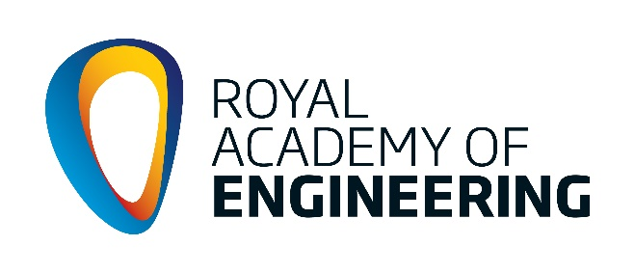
Barrow Engineering Project
Annual report 2018-2019
School: insert name here
In-school coordinator: insert name here

FOR GDPR COMPLIANCE - DO NOT MAKE SPECIFIC REFERENCE TO ANY NAMED PERSON OR PERSONAL DETAILS

Section A: How was the funding used? Please refer specifically to each of the 3 activities below. (maximum of 150 words for each activity)

- In-house funding for engineering activities (£500)
- Tomorrow’s Engineers Week activities (£150)
- British Science Week activities (£150)

In-house funding for engineering activities

Tomorrow’s Engineers Week (5th – 9th November 2018)

British Science Week (8th – 17th March 2019)

Section B: What impact have these activities made in your school and on your students (300 word guide)
Describe the impact in each of the following areas.

- Motivation and engagement in STEM and collaborative learning
- Increase in numbers of pupils participating in STEM activities – male/female opportunities
- Increase in Level 2 & 3 option choices of STEM focused subjects
- Wider skills (e.g. problem-solving, leadership, teamwork)
- An early interest in STEM/engineering careers

Section C: Scorecard

For all activities funded by the BEP and/or FESP, detail the activity that took place and the number of pupil beneficiaries, staff involvement, STEM Ambassador involvement and Employers involvement in each activity.

Details of Activity | Year Group | Male  Numbers | Female  numbers | Total  M + F  Numbers | Staff  Numbers | STEM  Ambs’ Numbers | Employers’  Numbers
TOTAL NUMBERS
Add additional STEM activities your school has been involved in.

Section D: Photographs and social media content

Add photographs and links to any school/college social media, website or newsletter mentions here.

copy and paste photos and links here

